

AMERICAN INTERNATIONAL UNIVERSITY–BANGLADESH (AIUB)
Dept. of Computer Science
Faculty of Science and Technology
CSC2210: OBJECT ORIENTED PROGRAMMING 2
Spring 2024-2025
Section: Q
Group No: 072

Project Report On
Restaurant Management System
Supervised By
Md. Hasibul Hasan

Submitted By:
Name | ID
1. GHOSH, ARGHA | 23-50804-1
2. ISLAM, SAMIUL | 23-51004-1
3. NAFI, NAFIUL ISLAM KHAN | 23-51154-1
Obtained Marks for CO2 and CO3 (Description given in the following page)
Assessment  Criteria | Not Attended/ Incorrect (0) |  | Inadequate  (1-2) |  | Average  (3) | Good  (4) | Excellent  (5)
Evaluation Criteria (CO2) |  | Total = |  | Evaluation Criteria (CO3) |  |  | Total =
Requirement fulfillment |  |  |  | Organization of the application
Validation |  |  |  | Representation and Integration of Database
Verification |  |  |  | Graphical User Interface

CO2: Display and verify the mean of a real-life Project using the concepts of C# Graphical User Interface based environment with database integration to depict a desktop-based application.
Assessment  Criteria | Not Attended/ Incorrect (0) | Inadequate  (1-2) |  | Average  (3) |  | Good  (4) |  | Excellent  (5)
Evaluation Criteria | Evaluation Definition
Requirement fulfillment | Fails to demonstrate any understanding of real-life scenario-based project development or functional requirement identification. There is no attempt to depict a project or identify functional requirements accurately. |  | Demonstrates limited understanding of real-life scenario-based project development and functional requirement identification. The project depicted lacks coherence or relevance to real-life scenarios, and functional requirements are inaccurately identified or insufficiently described. |  | Presents a basic depiction of a real-life scenario-based project and identifies some functional requirements. However, the project lacks depth or complexity, and some functional requirements may be vaguely defined or missing key details. |  | Effectively demonstrates a realistic scenario-based project and accurately identifies most functional requirements. The project is well-developed with appropriate complexity, and functional requirements are clearly articulated with relevant details. |  | Exhibits an exceptional understanding of real-life scenario-based project development and accurately identifies all functional requirements. The project is meticulously developed with thorough attention to detail, reflecting a comprehensive understanding of Object-Oriented Programming project development activities.
Validation | Fails to demonstrate any understanding or implementation of validation forms in their system. There is no attempt to deal with data validation, and validation requirements are completely ignored or incorrectly applied. |  | Demonstrates limited understanding of validation forms and data validation techniques. While some attempt may be made to implement validation, it is incomplete or poorly executed, leading to inadequate handling of data validation. |  | Shows a basic understanding of validation forms and data validation techniques. They attempt to implement validation, but some aspects may be missing or incorrectly implemented, resulting in partial or inconsistent handling of data validation. |  | Effectively demonstrates the use of validation forms and implements data validation techniques. Validation is mostly accurate and comprehensive, ensuring the proper handling of data input and verification in the system. |  | Exhibits an exceptional understanding and implementation of validation forms and data validation techniques. Validation is meticulously implemented with thorough attention to detail, ensuring robust data validation procedures and contributing to the overall reliability and integrity of the system.
Verification | Fails to demonstrate any attempt to verify the system data or functional requirements. There is no evidence of understanding or implementation of verification processes, and data flow is not considered. |  | Demonstrates limited understanding of verification processes and data flow in the system. Verification attempts are incomplete or inaccurate, and there is insufficient consideration given to ensuring data integrity and functionality. |  | Shows a basic understanding of verification processes and attempts to verify system data. However, verification efforts may be inconsistent or lack thoroughness, and there may be gaps in ensuring proper functional requirements and data flow. |  | Identifies and verifies system data, ensuring proper functional requirements are met. Verification efforts are mostly accurate and thorough, with attention to ensuring data integrity and appropriate data flow within the system. |  | Exhibits an exceptional understanding of verification processes and meticulously verifies system data. Verification efforts are comprehensive and precise, with a keen focus on ensuring all functional requirements are met and maintaining proper data flow throughout the system.

CO3: Prepare and Explain a real life desktop based application synthesizing several component of C# along with development tools to adhere the given requirements.
Assessment  Criteria | Not Attended/ Incorrect (0) | Inadequate  (1-2) |  | Average  (3) |  | Good  (4) |  | Excellent  (5)
Evaluation Criteria | Evaluation Definition
Organization of the application | Fails to identify any suitable real time application or requirements for project development activities related to OOP. |  | Limited understanding about the project scopes and scenarios or identification of functional requirements. |  | Lacks depth or relevance to OOP project development activities and may contain inaccuracies. Real-life scenarios are mentioned, but the discussion lacks depth or clarity. |  | Consider and integrate the idea of several core aspects of the project along with relevance to real-life scenarios. Demonstrating a solid understanding of the application presentation. |  | Generalize and exhibits an exceptional understanding of project preparation according to a to real-life scenarios. Also contains proper and insightful identification of the system which is comprehensive and precise.
Representation and Integration of Database | Fails to identify and present any understanding or implementation of database. Also failed to integrate the data with the project itself. |  | Limited understanding of the database concepts or their proper way of using in a real time project. While some attempt may be made to implement but it is incomplete or poorly executed, leading to inadequate design. |  | Lacks depth or relevance to database integration with the application. Shows a basic understanding but some aspects may be missing or incorrectly implemented, resulting in partial or inconsistency. May lack proper normalization. |  | Integrate the database with the forms properly and implements it with proper validation which is mostly accurate and comprehensive, ensuring the proper handling of data input and verification along with general normalization. |  | Exhibits an exceptional understanding and implementation of database ensuring attention to detail, and robust data manipulation procedures and contributing to the overall clarity.
Graphical User Interface | Fails to present or prepare GUI based application interfaces. There is no evidence of creating or integrating such things according to their usefulness. |  | Limited understanding of graphical user interfaces. Lack of design knowledge. Very poor attempt to make such things which are currently obsolete or can’t be identified as coherent. |  | Shows a basic understanding of creating user interfaces. Most of them are interconnected but maybe some of them lack it. However, most of it can be described as user friendly. |  | Effectively identifies and meet the consider the simplicity. Design related works are mostly accurate and taken proper attention to ensuring a user-friendly coherent system. |  | Exhibits an exceptional work design following a high standard of simple and elegant work. Several controls and mechanism has been organized in a preferred way according to the coherent usage .

Chapter: 01
INTRODUCTION:

The Restaurant Management System is a role-based desktop application developed to automate and streamline the day-to-day operations of a restaurant. The system is designed to support two primary user roles: Admin and Cashier. Each role has defined responsibilities and access privileges, ensuring secure and efficient task execution. The admin oversees user management, menu creation, inventory updates, and transaction monitoring, while the Cashier is responsible for handling customer orders, managing stock quantities, and processing various payment methods.

This project aims to reduce manual workload, minimize human errors, and improve service speed by introducing a digital system that centralizes restaurant management tasks. With features such as real-time inventory updates, detailed billing records, and controlled access based on user roles, the system provides a reliable and user-friendly platform to support both administrative and operational functions in a restaurant setting.

Chapter: 02

USER STORY

Admin Story:
The Restaurant Management System is a role-based application designed to manage and streamline restaurant operations efficiently. This system features two types of users: the admin, who owns and oversees the entire restaurant operation, and the Cashier, who is responsible for handling customer orders and managing transactions.

The admin holds the highest level of authority within the system and is responsible for both self-management and the supervision of cashiers. The admin can update personal information, including phone number, address, email, gender, and password. However, for security and ownership integrity, the admin account cannot be deleted from the system, and the role cannot be reassigned or expanded to others. The system is structured with the assumption that there will only be one Admin, representing the sole owner of the restaurant.

In addition to managing personal information, the admin has full control over cashier accounts. This includes the ability to add new cashiers, update all details of existing cashier profiles such as name, email, phone number, address, gender, and password, and delete cashier accounts when necessary. The admin can access comprehensive cashier records that detail transaction history, including which product was sold, its unit price, quantity, total sell amount, and the cashier responsible for processing each billing invoice.

The admin is also responsible for managing the restaurant menu and inventory. Through the Admin panel, new food items can be added by specifying the food name, category, price, and applicable VAT. Additionally, the Admin has the authority to modify the price and VAT of existing menu items. Once all administrative tasks are completed, the admin can log out securely from the system.

Cashier Story:
On the other hand, the Cashier’s role focuses primarily on customer service and order processing. To access the system, the Cashier must log in with valid credentials. Upon logging in, the Cashier can view the current inventory to check item availability. If an item is unavailable or running low in quantity, the Cashier has the ability to restock it by adding more units. However, the Cashier does not have the permission to modify item pricing or VAT details.

The Cashier is allowed to update certain personal information, specifically phone number, email, address, and gender. However, for identity consistency and security, the Cashier cannot change their name or password.

During the ordering process, the Cashier selects items as per the customer’s preferences and adds them to the cart. The system allows the Cashier to increment or decrement item quantities in the cart, add more items at any point, and review the full order with the customer before proceeding to the payment stage.

The system supports three distinct payment methods: Pay by Cash, Card Payment, and Mobile Banking. When selecting the Pay by Cash method, the cashier inputs the amount provided by the customer, and the system automatically calculates and displays the change due. Once the payment is confirmed, the order is finalized, and the transaction details are saved in the system.

In the case of Card Payment, a prompt guides the cashier to initiate a card scanning procedure. Upon successful transaction, the order is recorded. For Mobile Banking, the system offers Bkash, Nagad, and Rocket as options. The customer scans the payment code using their mobile device and completes the transaction externally. Once payment is verified, the cashier confirms the order, and the system automatically logs the record. After handling a customer transaction, the cashier can proceed to the next order or choose to log out if no other customers are waiting.

In summary, the Restaurant Management System effectively divides responsibilities between Admin and the Cashier to maintain operational clarity and security. The admin oversees system configuration, user management, and inventory control, while the Cashier focuses on day-to-day order processing and customer interactions. This structure ensures a balanced and reliable workflow within the restaurant environment.

Chapter: 03

ER DIAGRAM

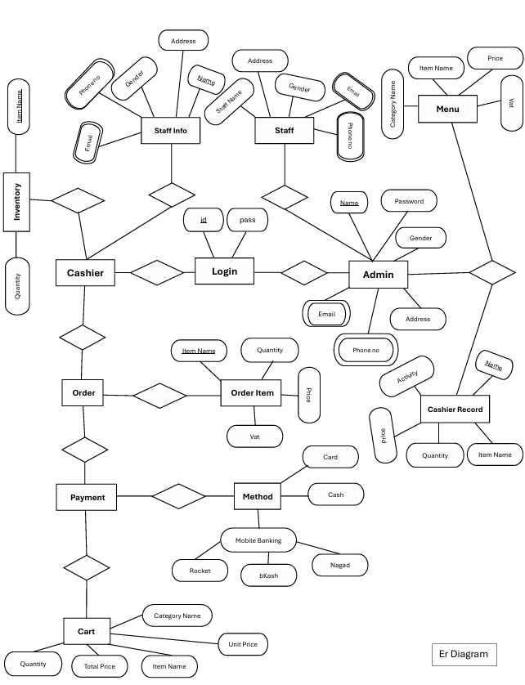

Chapter: 04

SQL QUERIES:

“SELECT ItemName, AvailableQuantity FROM [{category}]”

"SELECT * FROM [{category}]”

“SELECT CategoryName FROM CategoryTable”

"SELECT ItemName, AvailableQuantity FROM [{category}] WHERE ItemName LIKE @itemName"

"SELECT * FROM [{category}] WHERE ItemName LIKE @itemName"
For GetStaffInfo:

“SELECT Name, Gender, Email, ContactNo, Address FROM CashierUpdateInfo WHERE Name = @Name"

“SELECT Name, Gender, Email, ContactNo, Address FROM AdminTable WHERE Name = @Name"

"UPDATE AdminTable SET
Gender = @Gender,
Email = @Email,
ContactNo = @ContactNo,
Address = @Address
WHERE Name = @Name"

"UPDATE CashierUpdateInfo SET
Gender = @Gender,
Email = @Email,
ContactNo = @ContactNo,
Address = @Address
WHERE Name = @Name"

" UPDATE [{category}]
SET AvailableQuantity = AvailableQuantity + @AddQuantity
WHERE ItemName = @ItemName"

"SELECT MAX(ID) FROM CategoryTable"

"SELECT COUNT(*) FROM CategoryTable WHERE CategoryName = @category"

"INSERT INTO CategoryTable (ID, CategoryName) VALUES (@nextID, @category)"
"CREATE TABLE [{tableName}] (ItemName varchar(50) PRIMARY KEY, Price int NOT NULL, VAT float, AvailableQuantity int)"
"DELETE FROM CategoryTable WHERE CategoryName = @category"

"SELECT * FROM CategoryTable"

"SELECT COUNT(*) FROM CategoryTable WHERE CategoryName = @ctgry AND CategoryName <> @oldName"

"UPDATE CategoryTable SET CategoryName = @name WHERE ID = @id"

"EXEC sp_rename @oldName, @newName, 'OBJECT' "

"SELECT * FROM CategoryTable WHERE " +
"ID LIKE '%' + @search + '%' OR " +
"CategoryName LIKE '%' + @search + '%' "

"select * from ProductHistory;"

@"select * from ProductHistory
where entered_by like '%" + this.txtSearch.Text + "%' or name like '%" + this.txtSearch.Text + "%';"

"INSERT INTO ProductHistory (entered_by, name, activity, unit, total_value)
VALUES (@entered_by, @name, 'Sold', @unit, @total_value)"

"SELECT * FROM LoginList WHERE Username = '" + this.txtLogInEmail.Text + "' AND Password = '" + this.txtLogInPass.Text + "'; “ ;

"select * from CashierUpdateInfo;"

"select * from CashierUpdateInfo where Name like '" + this.txtAutoSearch.Text + "%';"

"update CashierUpdateInfo
set Name = '{this.txtName.Text}',
ContactNo = '{this.txtNumber.Text}',
Address = '{this.txtAddress.Text}',
Gender = '{this.cmbRole.Text}',
Email = '{this.txtID.Text}'
where Name = '{oldName}'"

"update LoginList
set UserName = '{this.txtName.Text}',
Password = '{this.txtPassword.Text}'
where UserName = '{oldName}'"

"select * from CashierUpdateInfo where Name = '" + this.txtName.Text + "';"

"insert into CashierUpdateInfo values('" + this.txtName.Text + "'," +
" '" + this.cmbRole.Text + "'," +
" '" + this.txtID.Text + "'," +
" ' " + this.txtNumber.Text + "'," +
" '" + this.txtAddress.Text + "'); "

"insert into LoginList values('" + this.txtName.Text + "'," +
" '" + this.txtPassword.Text + "', 'Cashier'); "

"select * from LoginList where UserName = '{user.UserName}';"

"update AdminTable
set Name = '{this.txtSUIname.Text}',
ContactNo = '{this.txtSUIcontactno.Text}',
Address = '{this.txtSUIaddress.Text}',
Gender = '{this.gender}',
Email = '{this.txtSUIemail.Text}'
where Name = '{user.UserName}'"

"update LoginList
set UserName = '{user.UserName}',
Password = '{this.txtNewPassword.Text}'
where UserName = '{user.UserName}'"

"SELECT * FROM {category}"

"SELECT CategoryName FROM CategoryTable"

$"SELECT * FROM [{category}] WHERE " +
"ItemName LIKE '%' + @search + '%' OR " +
"Price LIKE '%' + @search + '%' OR " +
"VAT LIKE '%' + @search + '%'"

$"SELECT COUNT(*) FROM [{category}] WHERE ItemName = @name"

"INSERT INTO [{category}] (ItemName, Price, VAT, AvailableQuantity) VALUES (@name , @price, @vat, 0 )"

"SELECT COUNT(*) FROM [{category}] WHERE ItemName = @NewName"

"UPDATE [{category}] SET ItemName = @NewItem, Price = @price, VAT = @vat WHERE ItemName = @OldItem"

"DELETE FROM [{category}] WHERE ItemName = @item"

"SELECT * FROM [{category}]”

Chapter: 05

PROJECT SCREENSHOTS:

